Names ______________________________________________________________________________
EDUC 2551 – Elementary School Math: Geometry
Project 3

1. A swimming pool is pictured below. Each end is a semicircle and middle section is a rectangle.
a. If you were to take a walk around the edge of the pool, how far would it be?
b. What is the area of the pool?
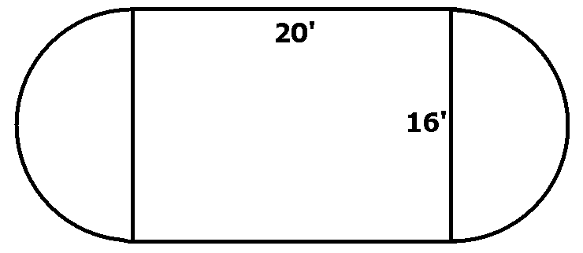

¹/₂ π × d= circumference of semicircle= ½*3.142*16=25.136

The perimeter of pool is= (25.136*2) + (20*2) = 50.272+40= 90.272

¹/₂ π*r²= area of semicircle= ½*3.142*8*8=100.544

Area of two semicircles 100.544*2=201.088

Area of rectangle= 20*16=320

Total area= 201.088+320=521.088

2. The following questions pertain to the figure below.
a. If each side has a length of 1 unit, find the areas and perimeters of L1, L2, and L3

Area of L1= (2*1)+(1
*1)
=3 units ²

Area of L2
(3*1)+(2*1)= 5 units²

Area of L3= (4*1)+ (3*1)= 7 units²
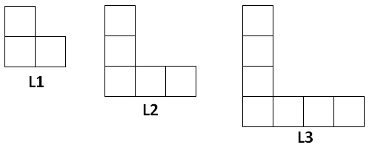

b. Draw L4 and find its area and perimeter;
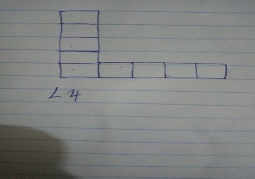

Perimeter of L4= 8 units

c. What is the formula for the perimeter of Ln?;
Perimeter of Ln= n+n= 2n

d. What is the formula for the area of Ln?

Ln= (n+1)*1+( n*1)
e. Find the area and perimeter of L10.

Area of L10= (10+1)*1+(10*1)=21 units²

3. a. Find the area of the triangle.

The area of triangle= area of rectangle- area of other parts that do not form triangle

=(1/2*1*4)+(1*4)+(1/2*2*3)+(1*4)+(1/2*2*4)=17 units²
Area of rectangle= 6*4=24

Area of triangle=24-17= 7units²
b. Find the perimeter of the triangle
=(√4²+2²)+(√2²+3²)+ (√1²+4²)= 12.198

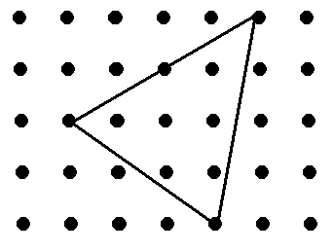
c.. Draw a line segment that is length of exactly $\sqrt{41}$units on the square dot grid below.

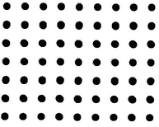
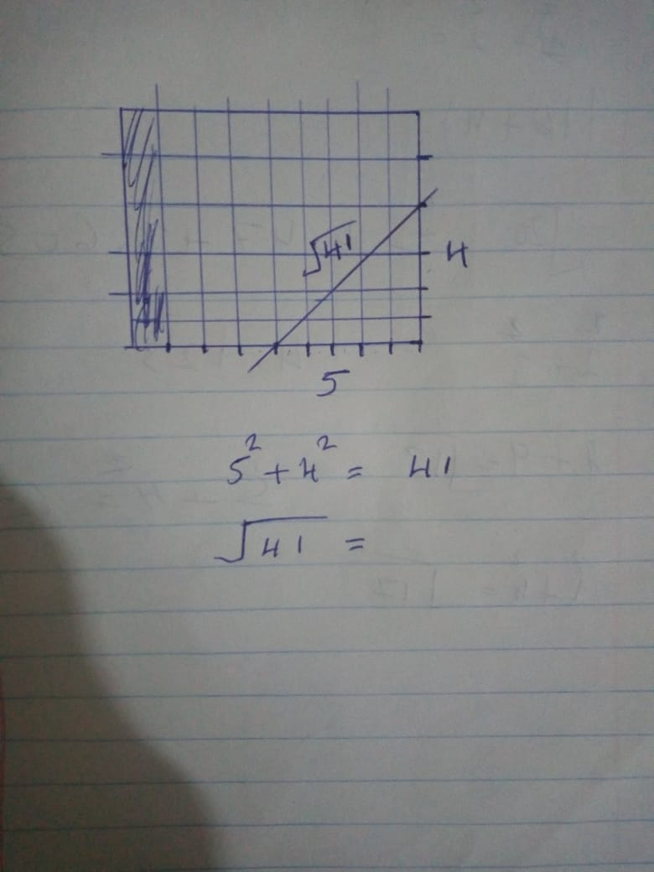

4. a. A square is inscribed in each of the circles below. The radius of circle A is 1 and the radius of the circle B is 2. What is the
ratio of the area of the square inscribed in circle A to the area of the square inscribed in circle B?
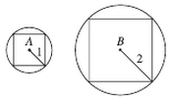
The ratio is 2/1=2
2²=2n²
^{n= 1.414}
4²=2n²

Ratio = 2.828/1.414= 2

b. The circle shown has a diameter of 6. Find the shaded area.
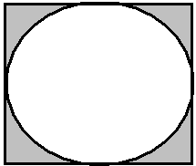

Area of square= 6*6=36
Area of circle= 3.142*3*3=28.278
Area of shaded part= 36-28.278=7.722

5. Find the sinA, cosA, and tanA.
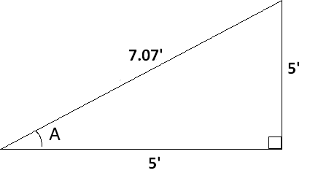

The sine of the angle = the length of the opposite side
the length of the hypotenuse
The cosine of the angle = the length of the adjacent side
the length of the hypotenuse
The tangent of the angle = the length of the opposite side
the length of the adjacent side
SinA= 5/7.07=0.707

Cos A=5/7.07= 0.707
Tan A= 5/5=1

6.
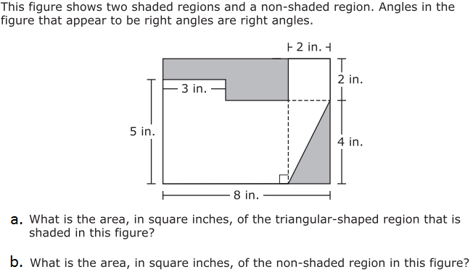

- Area of triangular-shaped region= ½*2*4= 4 in²
- Area of non-shaded region= Area of big rectangle- area of shaded part
Area of big rectangle= 6*8=48
Area of shaded part 1= (6*2)-(3*1)=9
Area of triangular shaded part=1/2*4*2= 4
Total area of shaded part= 9+4=13
Area of unshaded part=48-13=35 in²
.

